**DAILY ONLINE ACTIVITIES SUMMARY**

|  |  |  |  |  |  |  |  |  |
| --- | --- | --- | --- | --- | --- | --- | --- | --- |
| **Date:** | **08/06/2020** | | | | | **Name:** | **RITIKA KULKARNI** | |
| **Sem& Sec** | **4thSEM. & ‘B’ SEC.** | | | | | **USN:** | **4AL19CS403** | |
| **Online Test Summary** | | | | | | | | |
| **Subject** | | **COMPLEX ANALYSIS,PROBABILITY & STATISTICAL METHODS** | | | | | | |
| **Max. Marks** | | **30** | | **Score** | | | **20** | |
| **Certification Course Summary** | | | | | | | | |
| **Course** | **Introduction of Information Security** | | | | | | | |
| **Certificate Provider** | | | **Greatlearning**  **Academy** | | **Duration** | | | **5 Hrs.** |
| **Coding Challenges** | | | | | | | | |
| **Problem Statement:**   1. **Given a matrix, check whether it’s Magic Square or not. A Magic Square is a n x n matrix of distinct element from 1 to n2 where sum of any row, column or diagonal is always equal to same number.**   **Examples:**  **Input : n = 3**  **2 7 6**  **9 5 1**  **4 3 8**  **Output : Magic matrix**  **Explanation: In matrix sum of each**  **row and each column and diagonals sum is**  **same = 15**   1. **This algorithm partitions an integer into numbers which sum up to form the original number. It generates partitions of a set of numbers for a given range.** | | | | | | | | |
| **Status: Executed** | | | | | | | | |
| **Uploaded the report in Github** | | | | | **Yes** | | | |
| **If yes Repository name** | | | | | <https://github.com/ritikakulkarni/QuarantineCoding-C_Coding> | | | |
| **Uploaded the report in slack** | | | | | **Yes** | | | |

**Certification Course Summary: Today, I have learnt about the Indroduction of Information Security, Stanford Webinar - Hash, Hack, Code: Emerging Trends in Cyber Security (Dan Boneh) which helps to execute the code and to achieve the output and some of the basic security commands.**

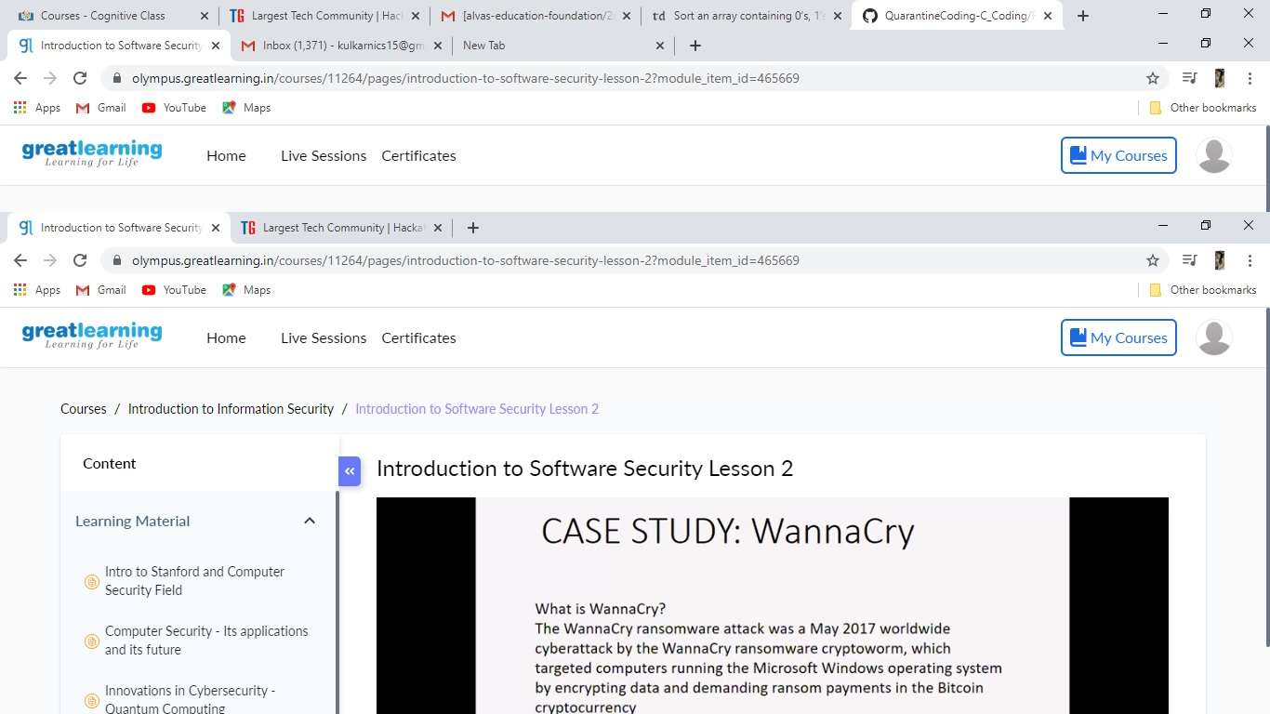

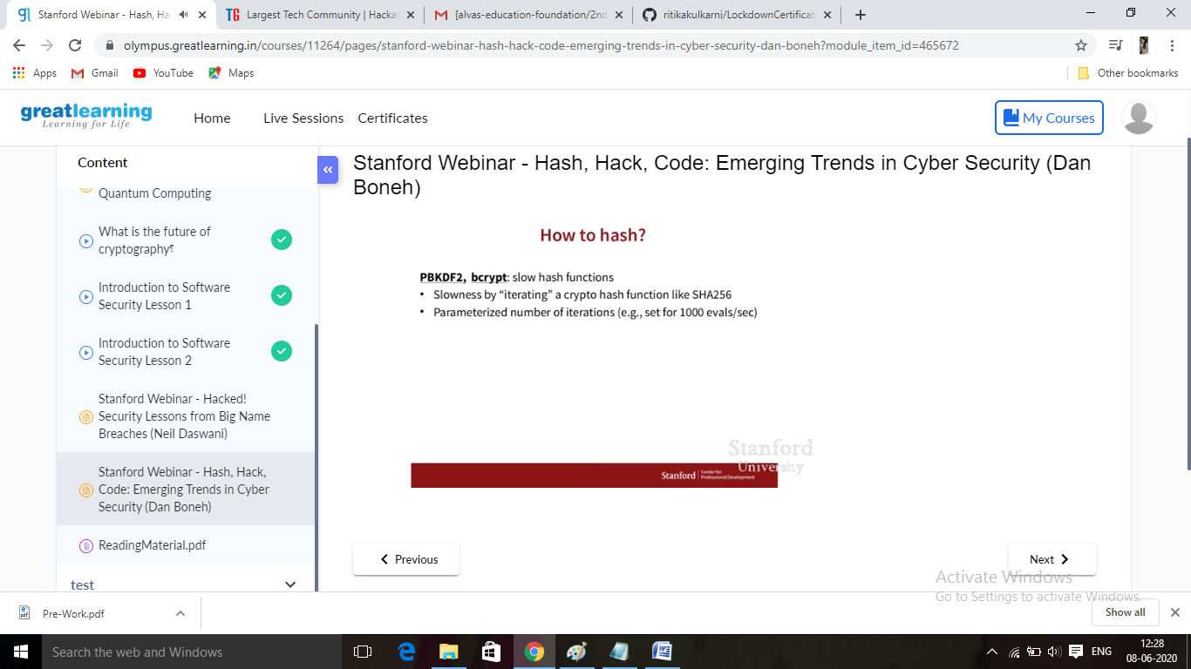

**Online Coding Summary:Online Coding Summary​: Online coding Summary: Today I received two program from Prof.Venkatesh CSE and Shilpa mam Dept. The program is mentioned above(pg.01). to my GitHub repository and I’ve shared the snapshot below.**

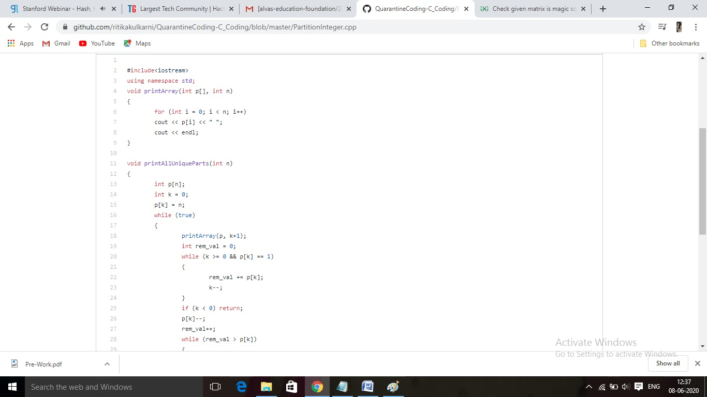

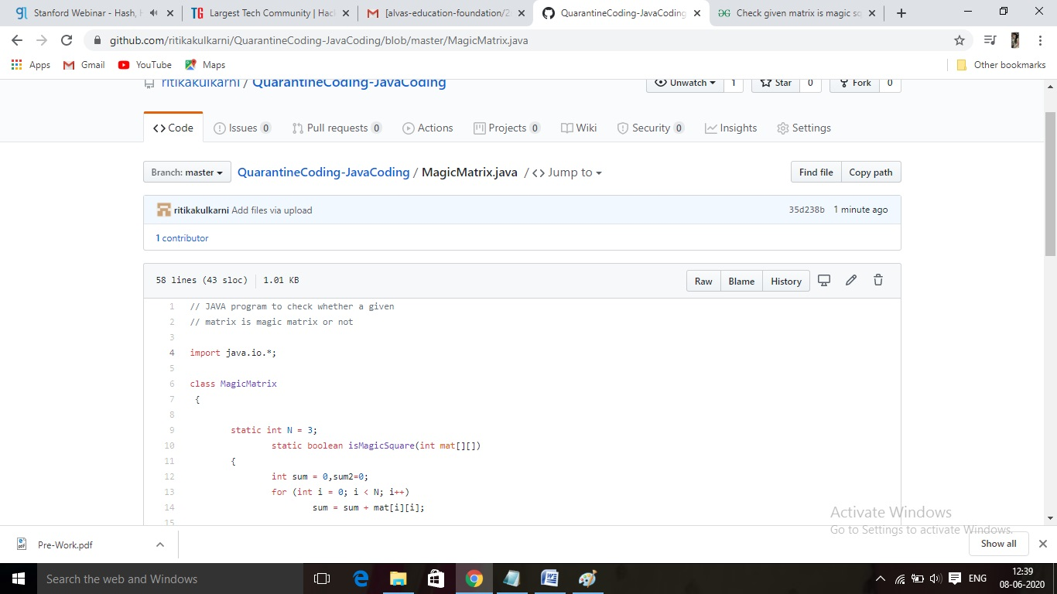 **Thank you.**